Oliver Collins-Cope

2102775@rutc.ac.uk

Learning Aim B & C

Design 2D and 3D digital graphics products to meet  
a client brief & Develop 2D and 3D digital graphics products to meet a  
client brief.

Unit 17 2d And 3D graphics

Assignment 2

Contents

Introduction 2

Design 2

2D Design 4

3D Design 5

Assets used 5

Design justification 6

Evaluation 6

Feedback 7

Changes made based on feedback 14

Developing graphics 15

2D Graphic 15

2D Optimisation 16

3D Graphic 16

3D Optimisation 20

Evaluation of Graphics 25

2D Evaluation against brief 25

3D Evaluation against brief 25

# Introduction

# Design

Throughout this section I will document the design of the overall graphic and also display the specific section for the 2D Graphic and 3D Graphic.

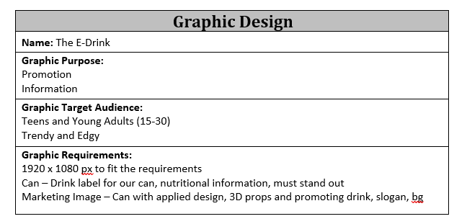

This displays the overall beginning of the design, ranging from the drinks name to the graphic requirements, such as 1920x1080 image. This helps to outline the direction that my drink should take in order to be successful from the client brief.

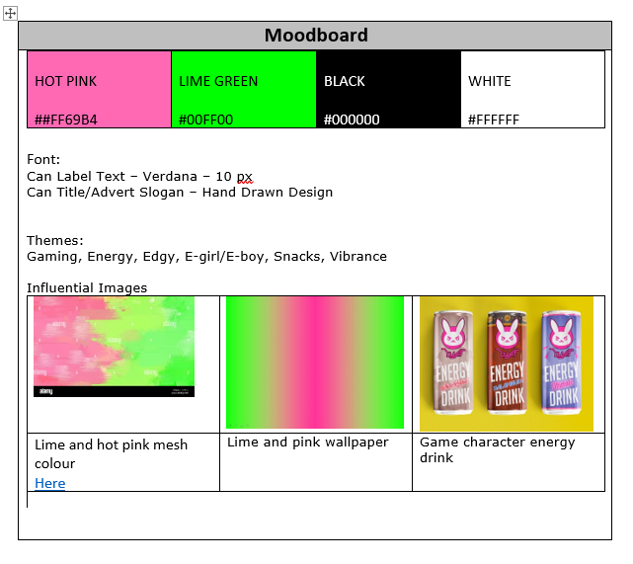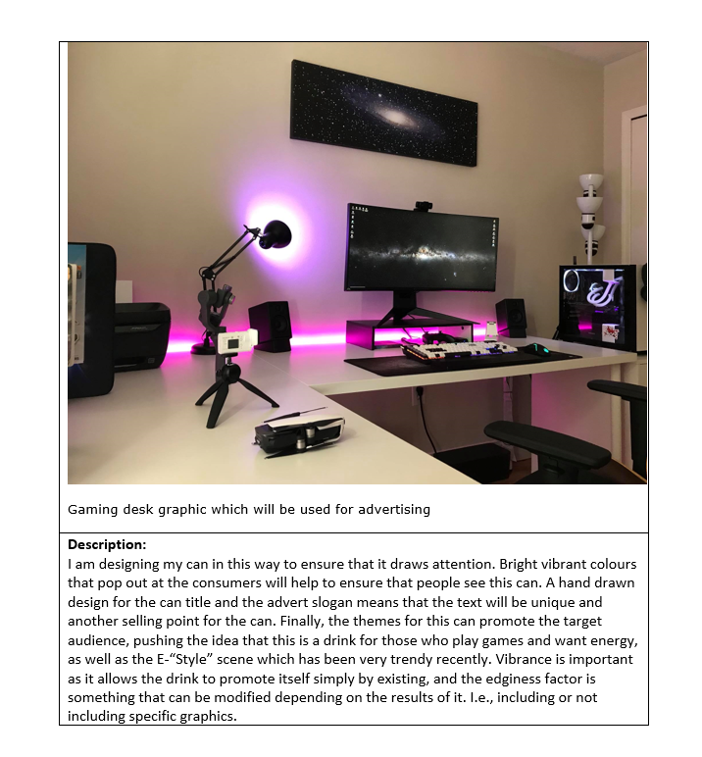

Here is the Moodboard that includes information about the design choices made here in order to ensure that the drink is successful once it is made and launched.

The text is included below:

“I am designing my can in this way to ensure that it draws attention. Bright vibrant colours that pop out at the consumers will help to ensure that people see this can. A hand drawn design for the can title and the advert slogan means that the text will be unique and another selling point for the can. Finally, the themes for this can promote the target audience, pushing the idea that this is a drink for those who play games and want energy, as well as the E-“Style” scene which has been very trendy recently. Vibrance is important as it allows the drink to promote itself simply by existing, and the edginess factor is something that can be modified depending on the results of it. I.e., including or not including specific graphics.”

## 2D Design

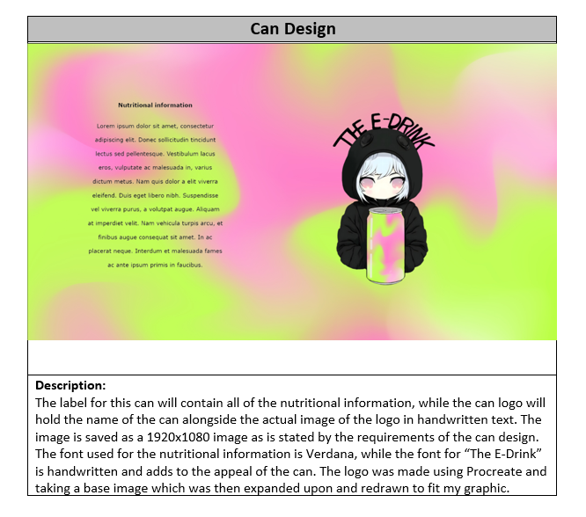

This is the initial design for the can that will be used. This is to be displayed the can and will contain all the nutritional information, while maintaining the colour and vibrant theme of the drink.

## 3D Design

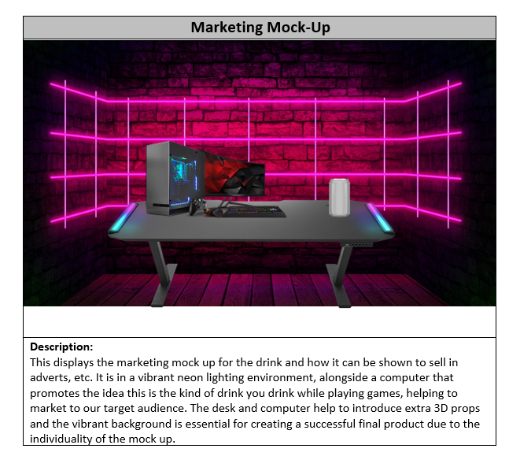

This is the initial 3D design made inside of a 2D image. It displays how the drink is supposed to stand on the table while near a gaming pc, promoting the idea that the drink is supposed to be drunk while playing video games.

## Assets used

Below is the list of assets used to create the 2D and 3D designs:

[marketing back ground mock up](https://pngtree.com/back/down?id=MTIyNjczNA==&type=1&time=1681931483&token=ZTQ5YjY3NzVkMzZjNTdkY2E5ZTY1ZTlkMmU2YjdkOTE=)

[original chibi image logo](https://www.google.com/url?sa=i&url=https%3A%2F%2Fwww.redbubble.com%2Fi%2Fposter%2FChibi-Anime-Girl-Drinking-Boba-Milk-Tea-Kawaii-by-Nymmzi%2F137657908.LVTDI&psig=AOvVaw3WMxFmCnF1xW1EmI0MQHby&ust=1682013907988000&source=images&cd=vfe&ved=0CBAQjRxqFwoTCOiTk57Etv4CFQAAAAAdAAAAABAE)

[background of can image](https://www.freepik.com/free-vector/gradient-pink-green-background_40125037.htm#query=pink%20green%20gradient&position=23&from_view=keyword&track=ais)

[pc original image in mock up](https://www.google.com/url?sa=i&url=https%3A%2F%2Fwww.overclockers.co.uk%2Fwelcome-to-pc-gaming&psig=AOvVaw1Yfcj8OM2Fn1x4U8xMLzdZ&ust=1682018096626000&source=images&cd=vfe&ved=0CBAQjRxqFwoTCIjNvevTtv4CFQAAAAAdAAAAABAF)

[blank can original link](https://www.google.com/url?sa=i&url=https%3A%2F%2Fwww.vecteezy.com%2Fpng%2F12041389-drink-can-blank-mockup&psig=AOvVaw1tocjoUOXPZCRgJVXzyF13&ust=1682018059087000&source=images&cd=vfe&ved=0CBAQjRxqGAoTCNj4wNnTtv4CFQAAAAAdAAAAABCtAg)

[desk image original link](https://www.google.com/url?sa=i&url=https%3A%2F%2Fcougargaming.com%2Fproducts%2Fdesks%2F&psig=AOvVaw0If5jelU0CZVn6GKK7RaN_&ust=1682018507938000&source=images&cd=vfe&ved=0CBAQjRxqFwoTCLiIyq_Vtv4CFQAAAAAdAAAAABAU)

I have used these above images in my mock up design as this allowed me to create an accurate design that could be used later on in the creation of the actual 2D and 3D graphics. Additionally, they were used due to the fact that they suited the initial idea and theme of the product that I have developed internally and now I am just beginning to express that idea within the design.

The file format used for all of the images has been PNG, as this is a lossless file format type, and although the images might be slightly larger in terms of storage/size, I believe this is worth it to maintain quality. This theme of using PNG will remain consistent throughout the whole project.

Finally with regard to the copyright, all of the authors stated that their assets, both future 3D and 2D are able to be used commercially and privately as long as there is credit provided, which has been done through the links provided throughout this document.

# Design justification

For the 2D design, I ensured that the decisions I made, while developing and creating the designs, were justifiable and helped to provide an effective solution to the client brief.

In order to meet the requirements of the project, I have used bright and vibrant colours with bright green and hot pink in my design. These colours were chosen to make the can design stand out and grab the attention of the target audience, which is likely to be on the younger side. The bright green and hot pink colours create a sense of excitement, which aligns with the purpose of the product.

To further enhance the appeal of the design, I have added a hand-drawn logo. The hand-drawn logo adds a personal touch, and this hand-drawn element also contributes to the overall vibrancy of the design, making it more memorable and engaging for the audience. The combination of the vibrant colours and hand-drawn logo not only fulfils the client's requirement of a can design that stands out on shop shelves, but also aligns with the target audience and purpose of the product. The bold colours and hand-drawn logo contribute to creating an effective solution that captures the attention of the audience and communicates the energetic and refreshing nature of the beverage, in line with the client's brief.

For the 3D design that I made, I made sure that the design that was created was following the same theme of gaming and mixing the drink in with that kind of environment.

The 3D mock-up design features a vibrant neon background, a gaming PC and monitor image, and a blank aluminium can prominently displayed on a table. The neon background with bright pink colours creates a visually appealing and attention-grabbing backdrop that resonates with the target audience, likely gamers.

The gaming PC and monitor image adds a modern touch to the design, conveying the message of the drink’s relevance to gaming. The placement of the blank aluminium can on the table draws attention to the drink. The use of 3D graphics will add depth and realism to the design, making it more engaging and impactful.

Overall, these design decisions align with the client's requirements, target audience, and purpose of the product, creating an effective solution for the marketing campaign. The design captures the audience's attention and communicates the drinks message effectively on marketing screens with its dimensions of 1920 x 1080px.

# Evaluation

The journey of creating my 2D and 3D design led to me expanding on the initial ideas I had for my designs, which were limited to simple sketches that could simply be thrown together easily. By introducing the idea of a hand-made logo and hand-written text. The vibrancy of both of the designs also helps to promote the drink to the target audience and age group, therefore ensuring that the drink will sell well. With regards to the design of the 2D can, I made sure that the idea of it embodies the kind of drink it aims to represent, full of energy, colourful, and vibrant. The focus on these features means that the drink will be pushed forward in its best form, ensuring as many purchases as possible.

To conclude, I believe that the design decisions I made were extremely justifiable, as they promoted my drink well while also following the client brief. Additionally, I also made sure that it appeals to the target audience through the use of vibrant colours, hand-drawn logos, and any relevant image design techniques that might be applicable for the drink.

# Feedback

Below is the feedback I received alongside the questions that were asked.

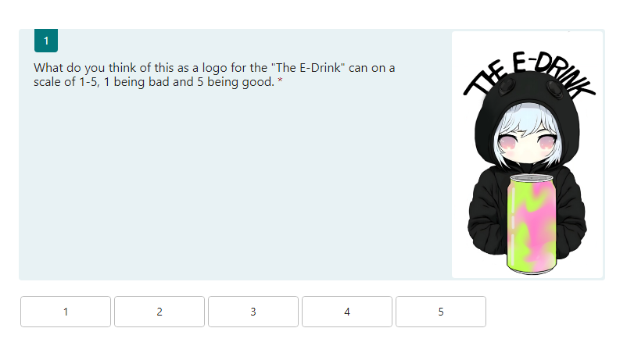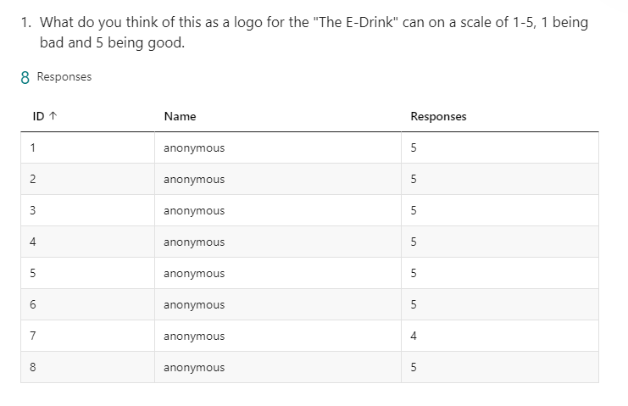

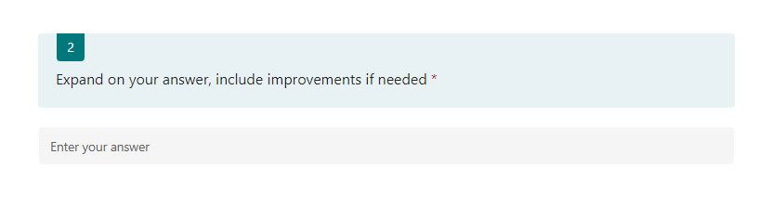

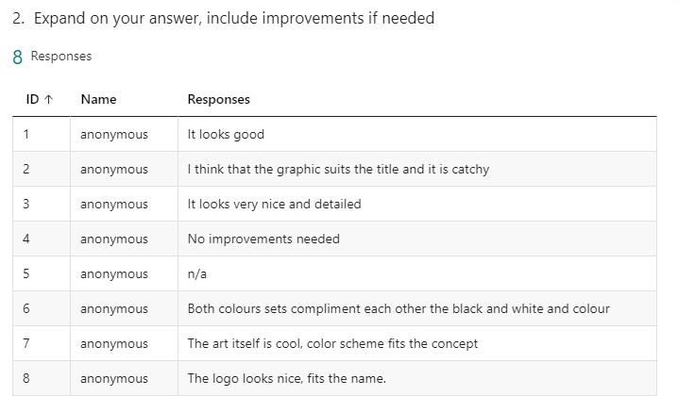

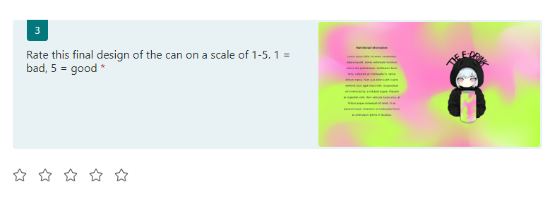

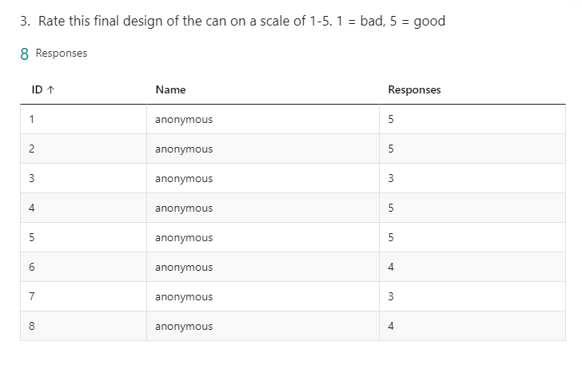

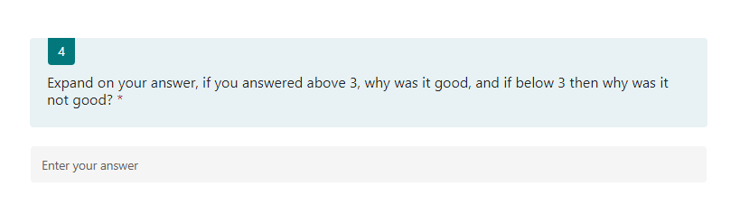

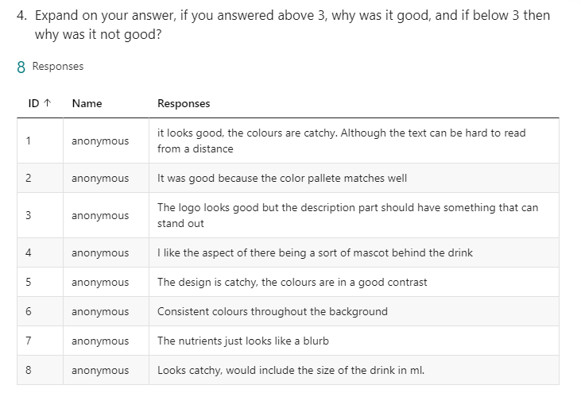

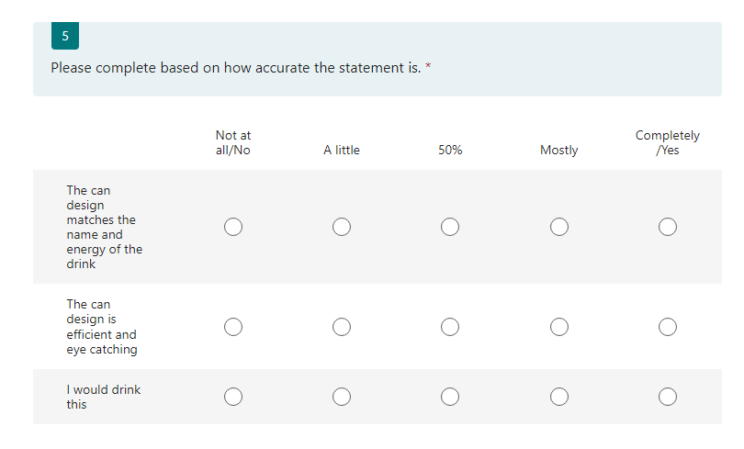

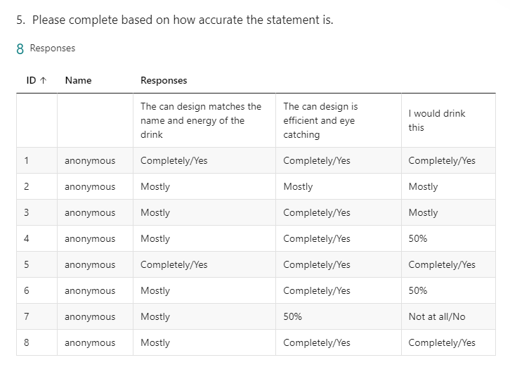

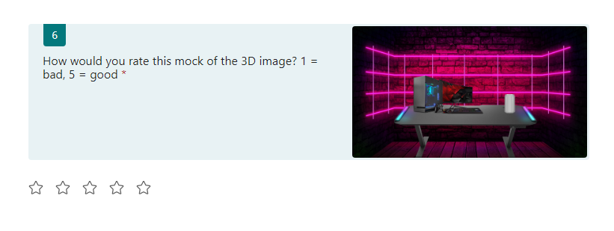

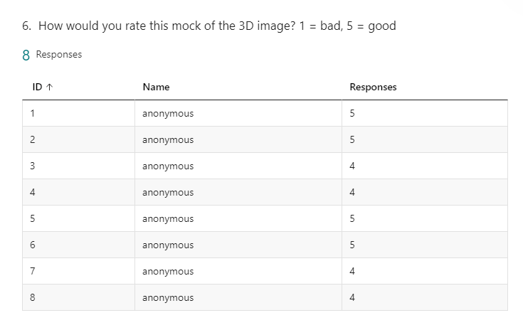

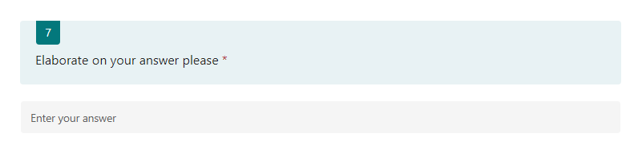

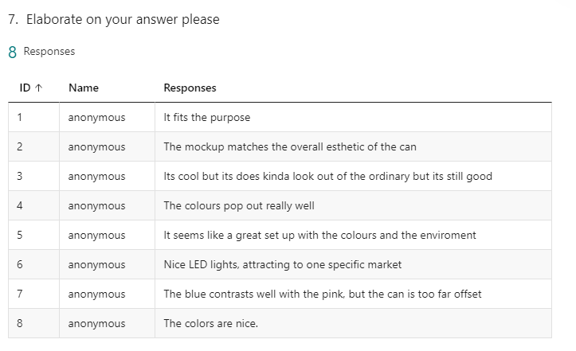

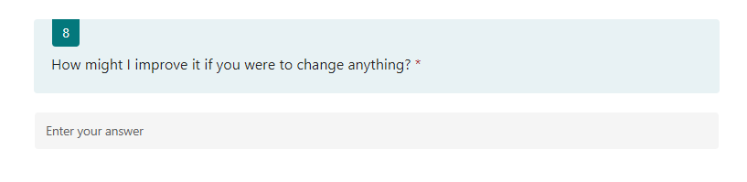

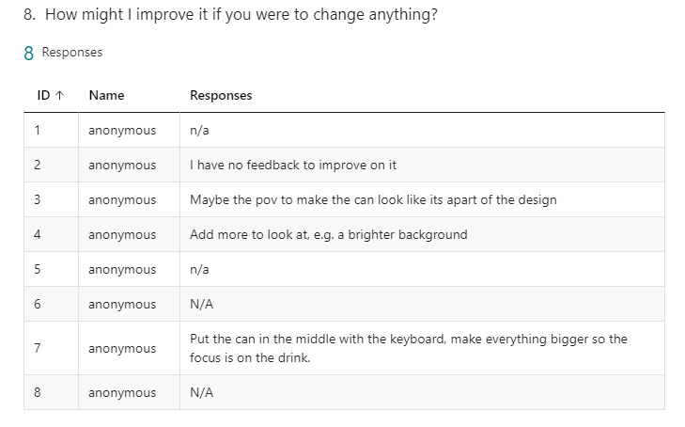

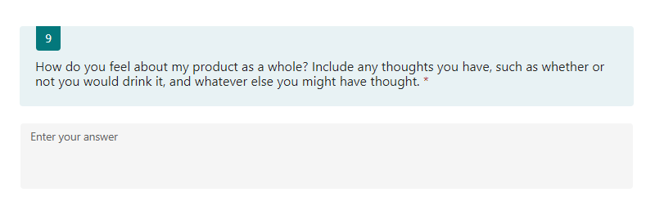

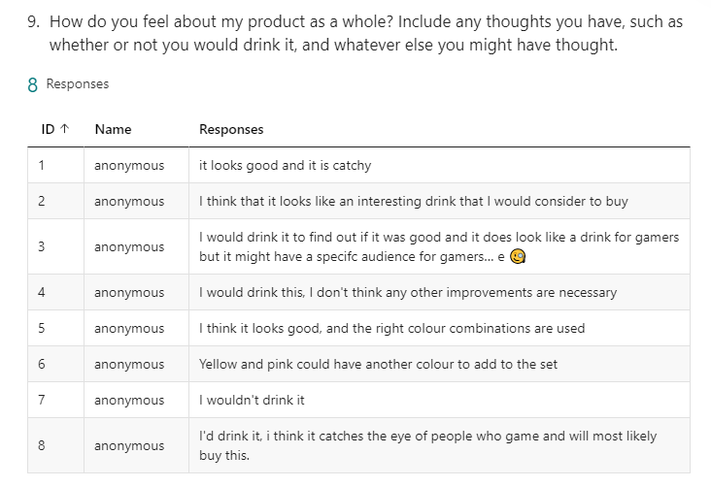

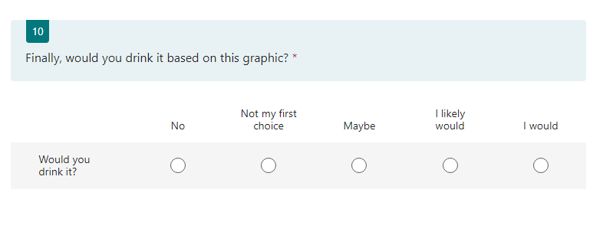

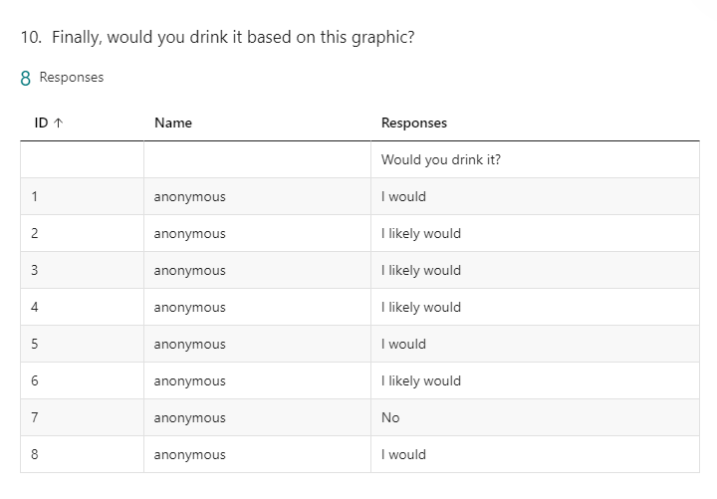

This is the feedback I received from my peers. Following this, I will be making changes to my designs based on this in order to improve the quality of my final product and this will allow for a successful project.

## Changes made based on feedback

Based on the feedback I received, I made some changes to the 2D image. First of all, I changed the design to include the size of the drink in a vertical style which is unusual and unique among other drinks. The font type for this was also Verdana with a font size of 16, and was also bold.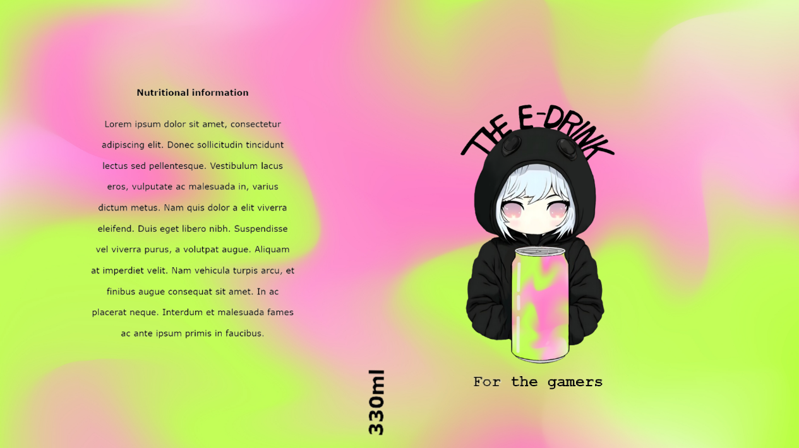

Following this, I also took to adding a slogan to the drink. The goal of introducing this slogan was to add more detail the drink, while also making it clear what the target audience of this drink was. The font type used was a monospace font, which means all the characters are equally spaced, called Couriers New, and this is because the aesthetic of monospaced fonts is unique and fits well with the design of my can.

For my 3D design, I took the advice of moving the can to the centre of the screen in order to have it be the central focus, while also including some new props like a chair to make the desk scene seem more natural. Finally, I included some additional plants in order to bring more natural life into the image and promote the idea that this drink is also naturally good for you.

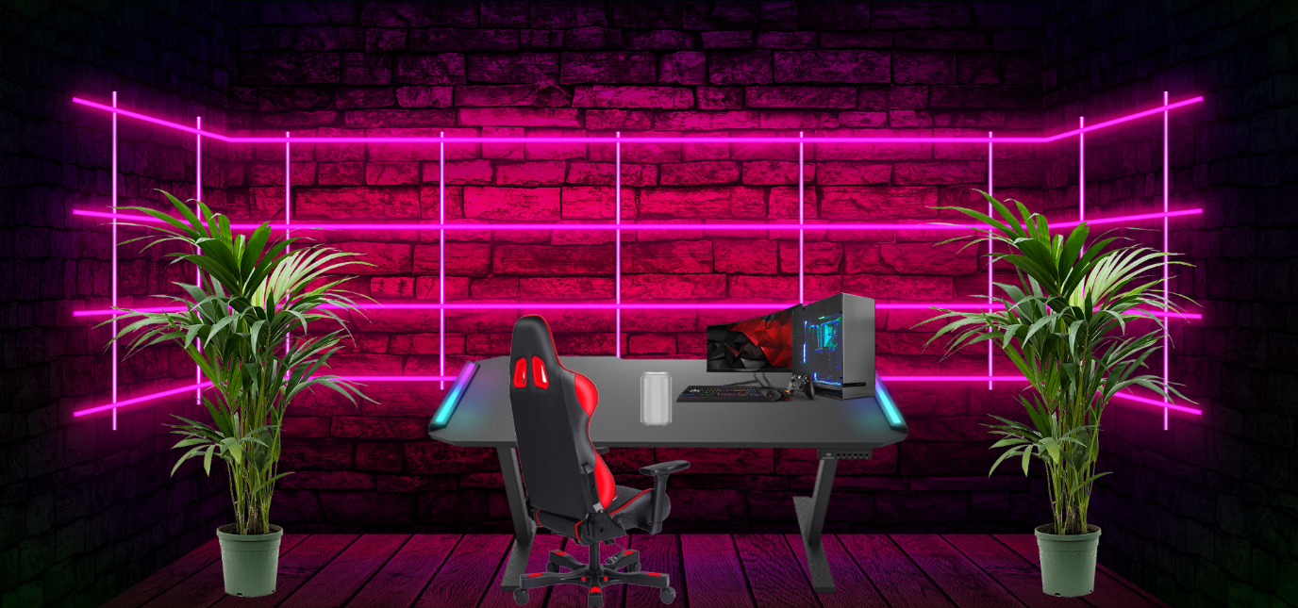

The arrows and circles display the changes made to the mock design graphic.

The new version of the 3D mock feels much livelier and more authentic compared to the prior graphic.

# Developing graphics

## 2D Graphic

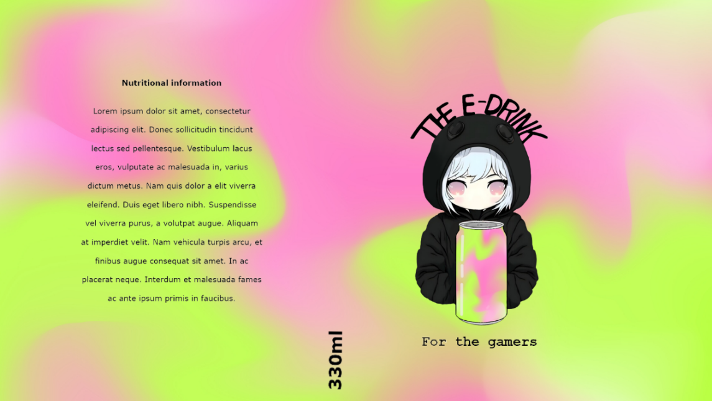Following the designs I made, I found that I was actually quite satisfied with the final result of them, and I wish to use them as is. This means that my 2D Graphic before any optimisation will be this image:

The process of developing this design was documented prior, however as a quick summary, The logo and name of the drink was hand drawn, the text on the left is written in Verdana and contains the nutritional information of the drink, alongside the size of the drink in the middle also in Verdana. Finally the marketing slogan is in Couriers New as it is a monospace font which I believe will work well.

The questions for the 2D and 3D optimisations of the graphics will be the same.

### 2D Optimisation

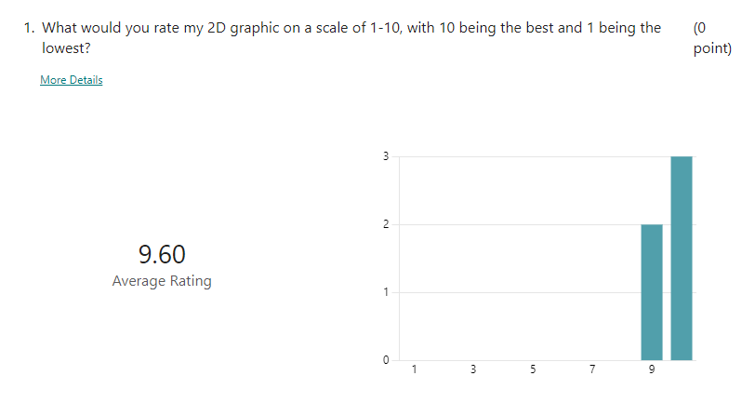

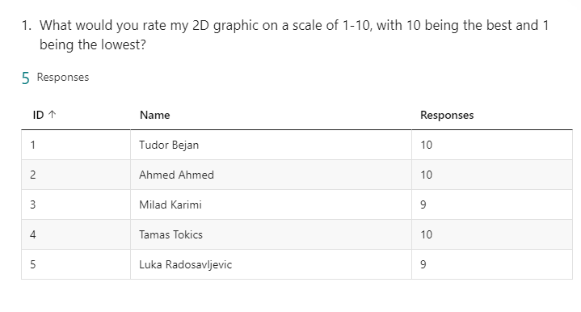

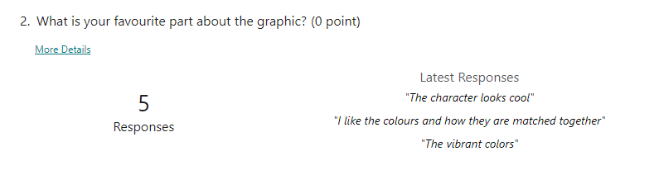

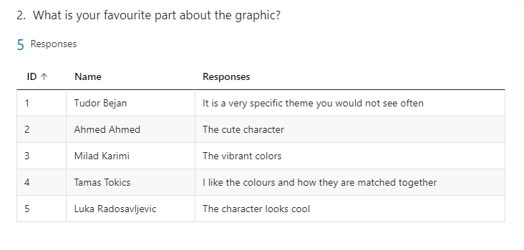

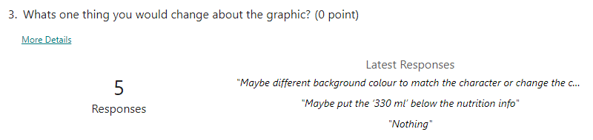

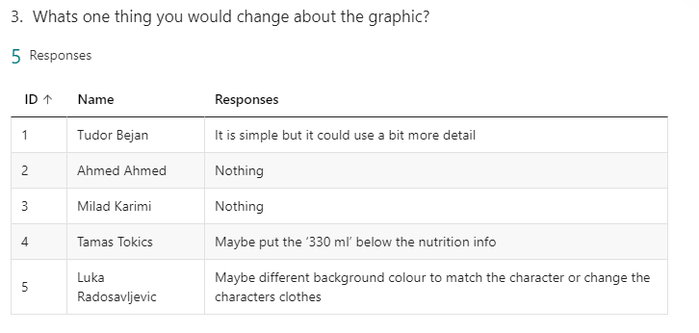

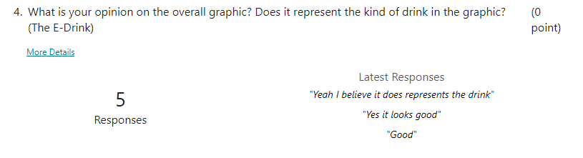

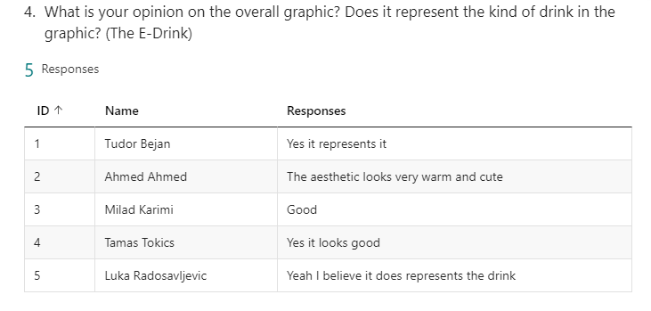

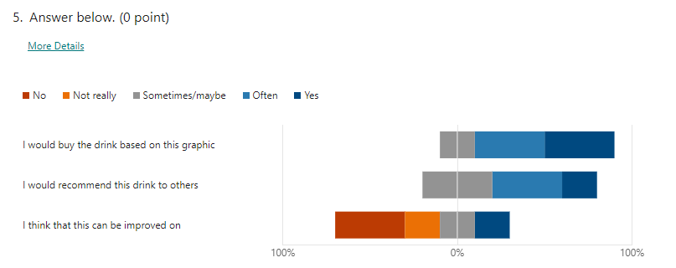

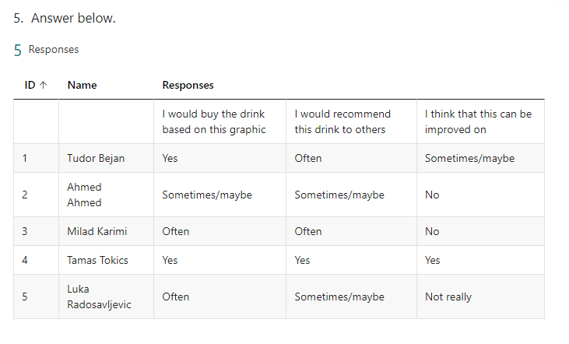

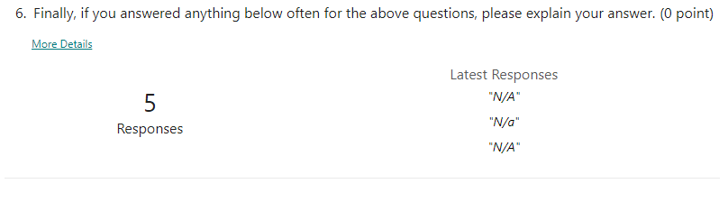

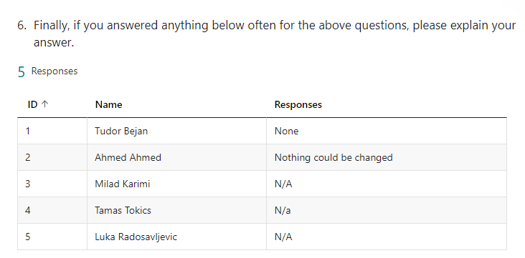

Following this feedback, I will modify the 2D Design to have the 330ml under the nutritional information, as well as having more details put on the can to help separate it and enhance the image. These changes made can be seen below:

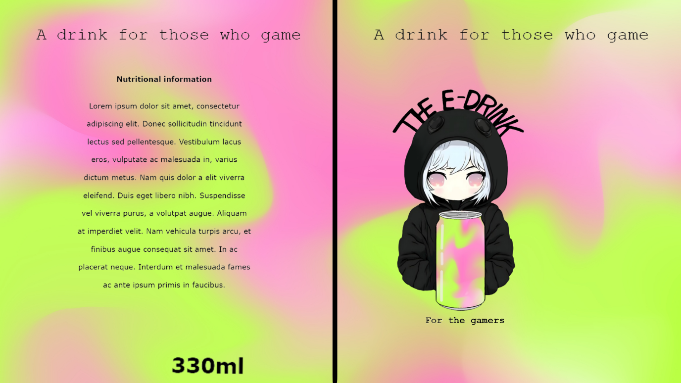

This is the final graphic. The logo is intentionally placed off centre to lead it closer to the nutritional information. I added a visible line separating the logo and nutritional information as I believe that the black and colours contrast each other very prettily. Additionally, I made the change of moving the drink size under the nutritional information, and also added a further slogan at the top that will wrap around the top of the can, reinforcing the idea that the drink is for gamers.

## 3D Graphic

Here is a list of all of the assets I have used for this 3D graphic

[Table](https://sketchfab.com/3d-models/gaming-table-2813ff817fb34e3dbfe3608fb98370b5)

[Low poly plant](https://sketchfab.com/3d-models/low-poly-style-plant-f4d845cddae04bf692bc9a9245524de1#download)

[Monitor](https://sketchfab.com/3d-models/monitor-0f3d348a29c14242bf79d0560f027af1)

[PC](https://sketchfab.com/3d-models/low-poly-gaming-computer-emapale-computate-be9cc8d7602f4f0cbbb001564eb0f7c3)

[Keyboard](https://sketchfab.com/3d-models/keyboard-low-qualty-texture-w-ppo-3e9ed4020f7f4784ae8a4bc9f65bc2b0)

[Chair](https://sketchfab.com/3d-models/low-poly-computer-chair-6148d2bbb5b041209dd3f021f476c320)

All of these above assets are allowed to be used both commercially and privately, so long as credit is provided to the original author, and these can be found by following the above links to their original download pages.

The screenshots below document the development of creating the 3D marketing scene, along with any evolutions that occur. This first screenshot was taken once the base for the image had been developed, specifically the PC, Cans that display the logo, and the table. This was a good starting point for my 3D scene to develop as it shows how the initial idea came into play, and it was just a matter of making everything fit with the final scene later on.

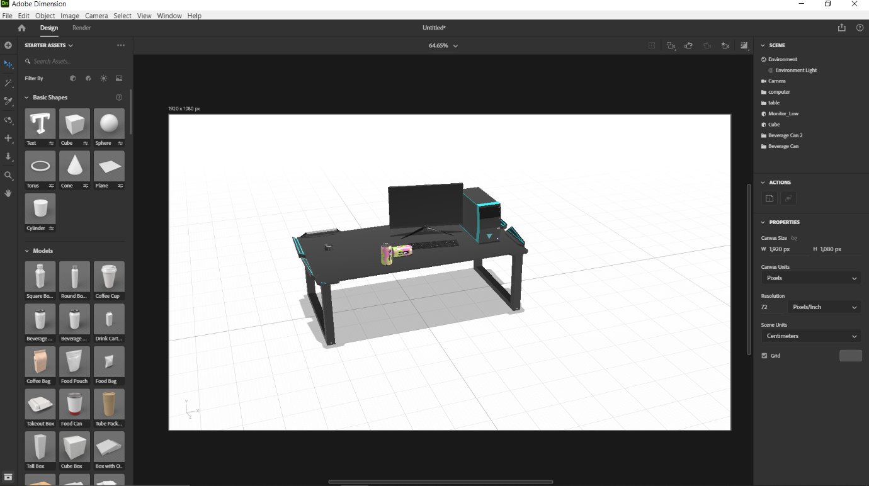

This next screenshot depicts how I had found the models I would like for my graphic for the chair and plants. These are both low poly as I wanted to keep the performance of my device in mind when creating this and so I avoided models with a high number of vertices and triangles as my laptop had struggled with these previously.

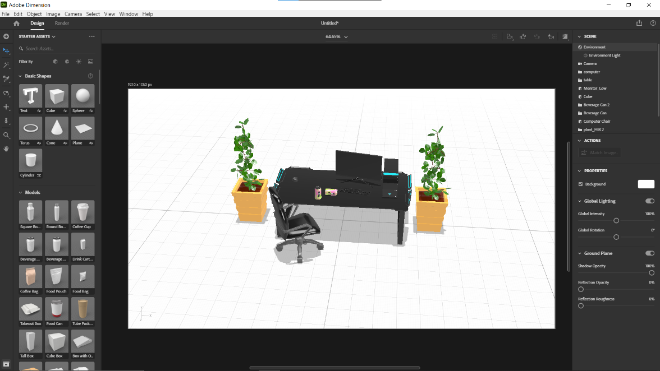

This next image depicts how I went on to implement lighting in the scene. Knowing that I was going to use a neon pink background helped me decide what colour and what intensity I should set my lighting to, and overall allowed me to successfully set up my lighting for my 3D marketing image.

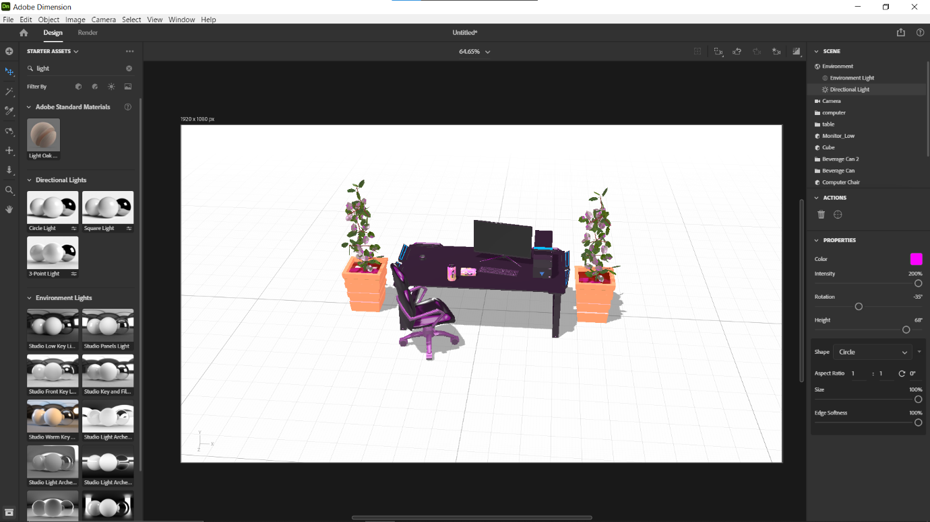

This was once the 3D background had been implemented. All of the props were not in a good position for the rendering so I took the time to reposition them and the camera for a high quality render.

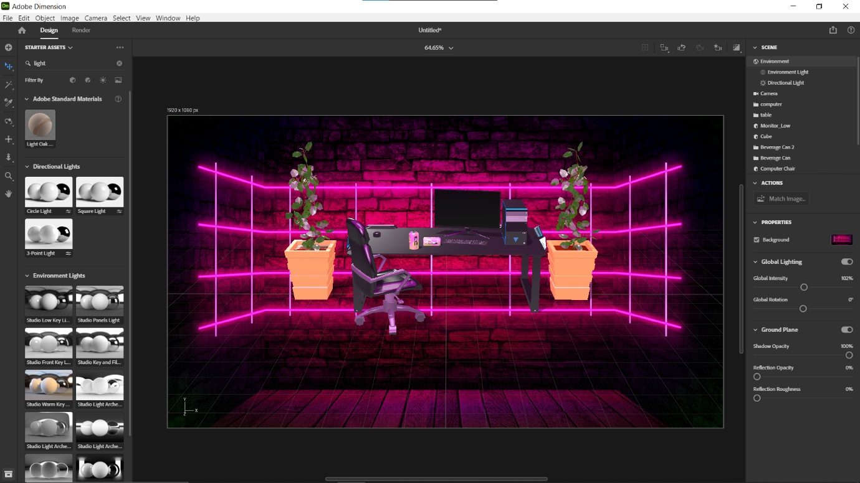

This was the finished result of my work for the 3D marketing graphic. I positioned everything as I had wanted and, after taking one more screenshot, proceeded to render.

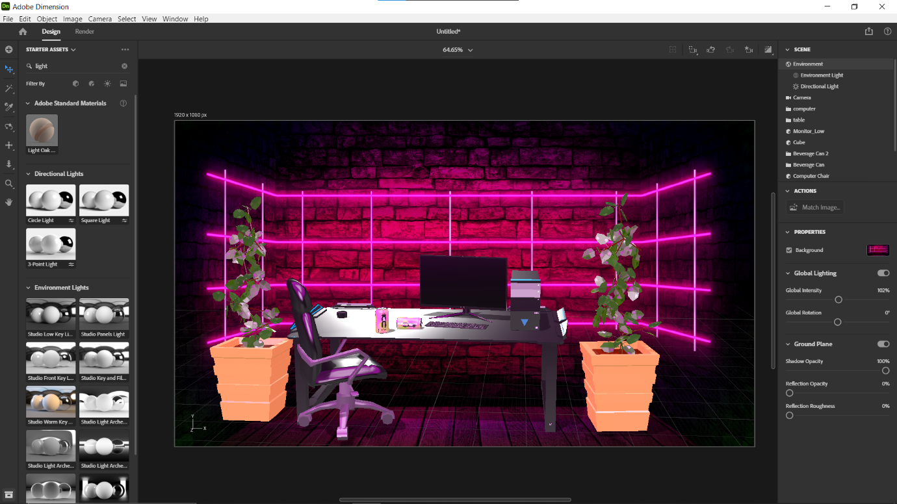

This was the last screenshot taken, simply displaying how the can drink graphic looks on the can, allowing for the viewers of the 3D marketing graphic to truly see the drink in its element.

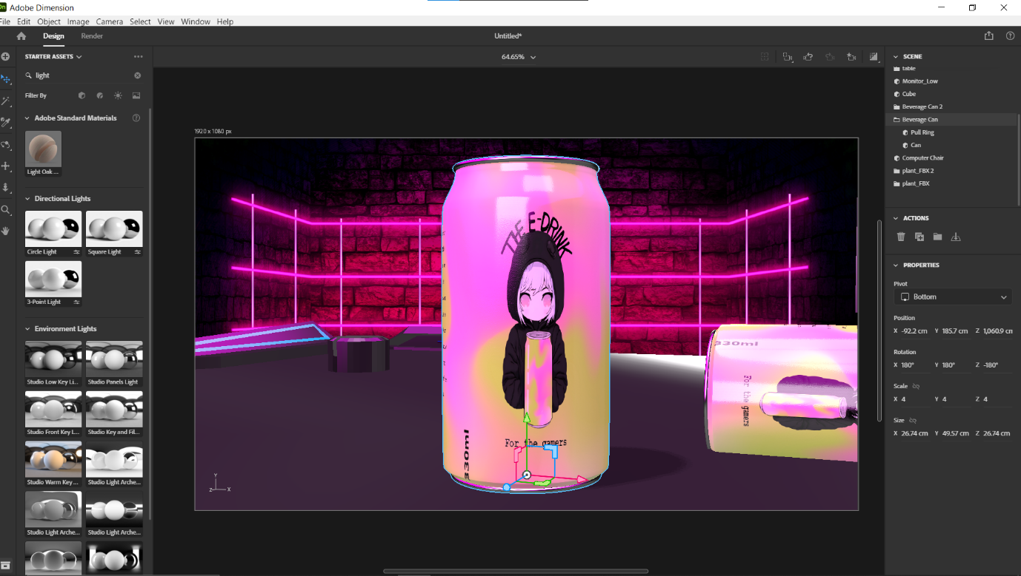

Finally, this is my 3D graphic rendered to the highest quality, ensuring that the quality is satisfactory. I made sure to include many props in order to meet the client requirements, alongside having a matching background and many other necessary themes to meet the clients requirements for my 3D marketing graphic.

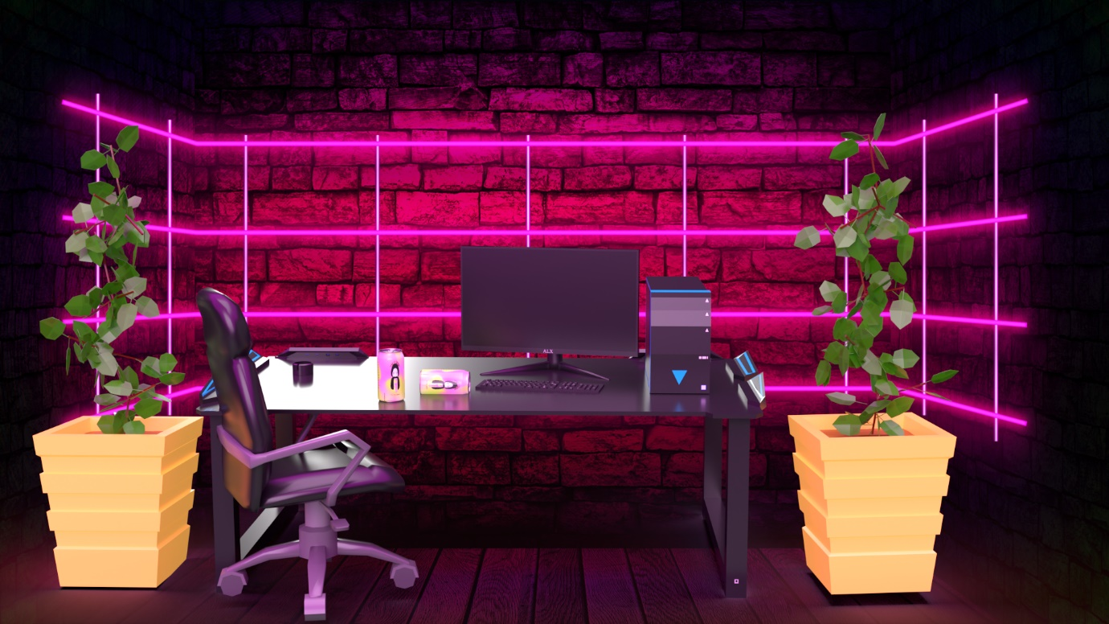

### 3D Optimisation

Below are the questions I asked and received answers for, in regard to the feedback for my 3D marketing graphic.

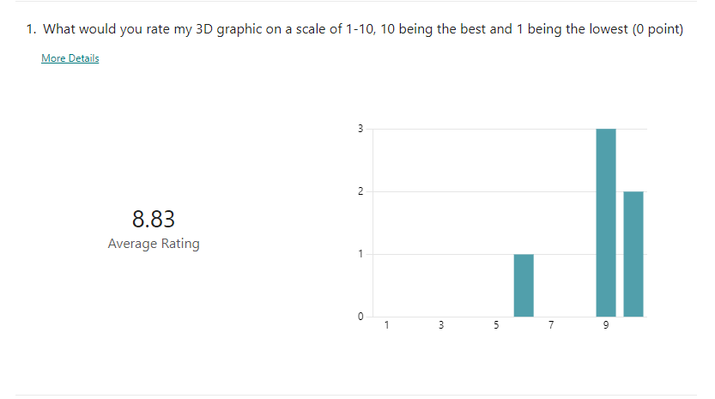

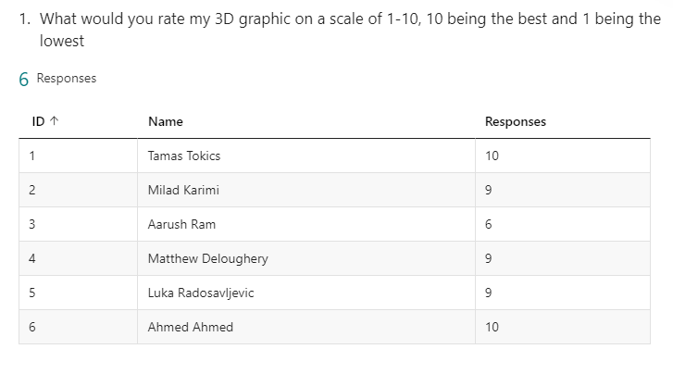

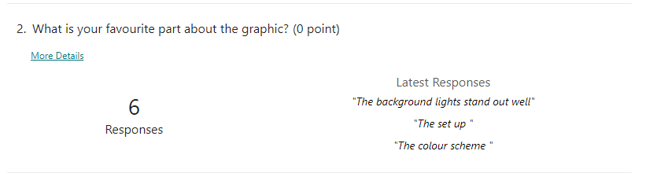

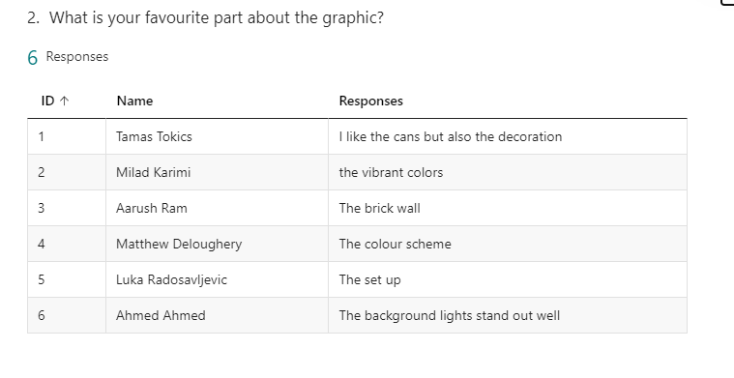

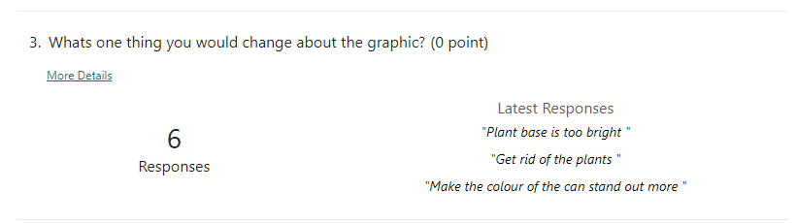

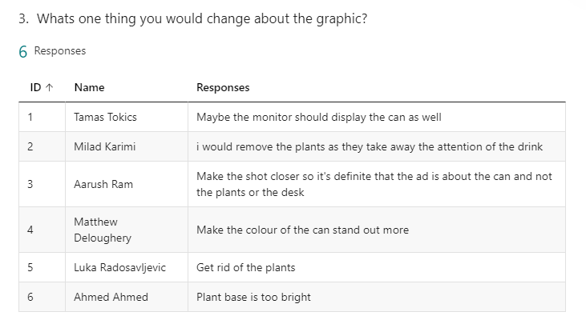

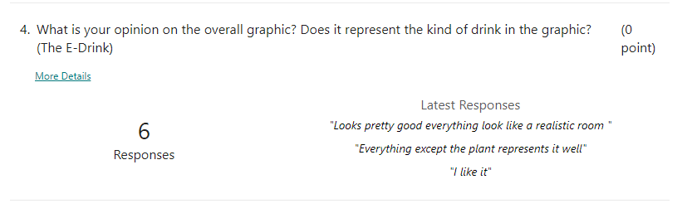

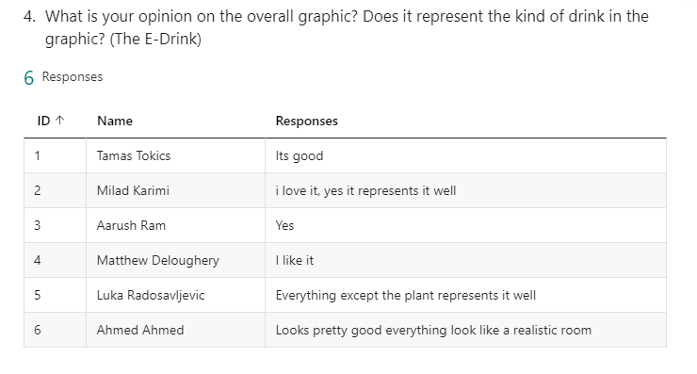

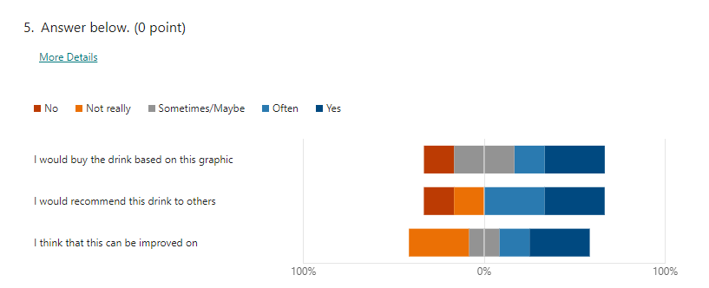

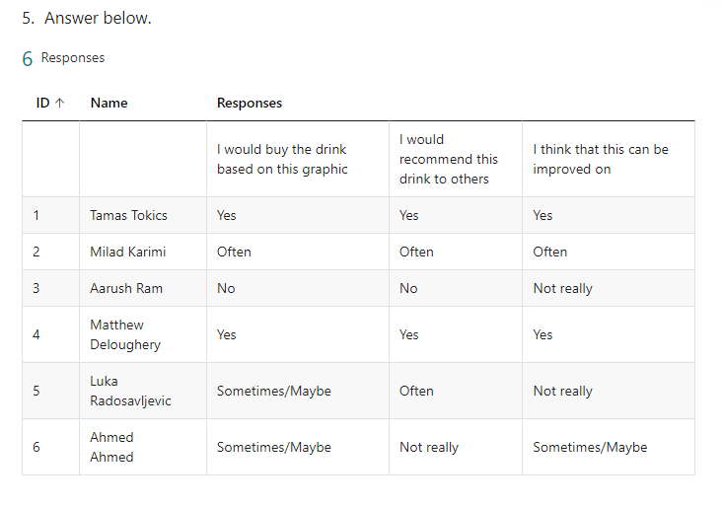

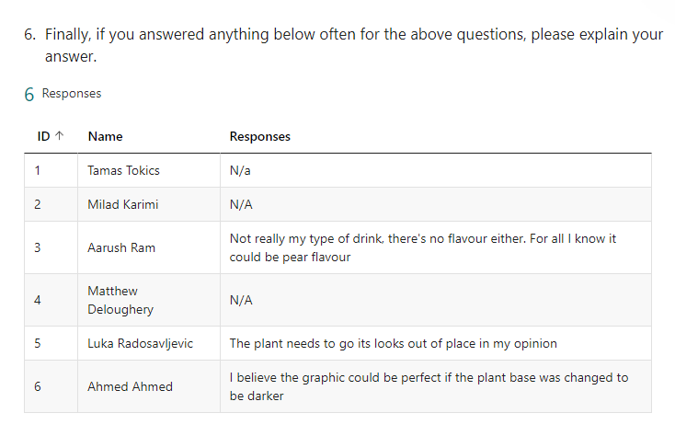

Following the feedback, a lot of focus seems to be on the plants, either how the colour is out of place or the whole plant itself is out of place, and so I believe that I will be removing them in order to enhance the visual. Additionally, I will also make the change to bring the camera closer to the can in order to cement the fact that this is an advert for the can itself, and not the whole setup.

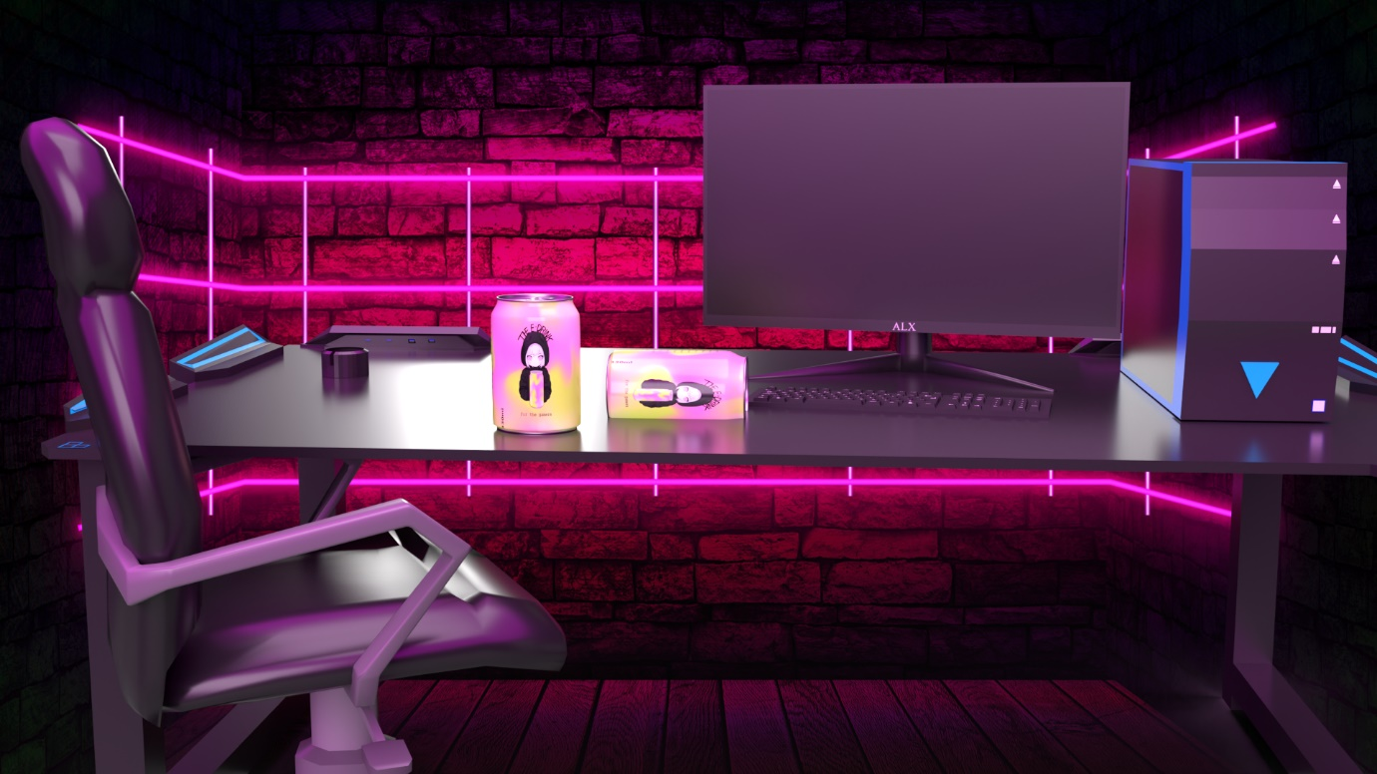

This is the final optimised graphic; I also ensured to largen the can and make sure that the focus is on it. The final product of this graphic is that there is a large focus on the can, while removing anything that seems out of place and therefore ruining the marketing graphic. Additionally, the high quality, which is shown through things like reflections on the table, is also adding to the quality of the image and raises the overall worth of the graphic.

# Evaluation of Graphics

## 2D Evaluation against brief

Throughout the journey of creating my 2D graphic, there were many design elements that I used, such as hand drawn logos and different text fonts, while also focusing on enhancing the nutritional information to be displayed easily and without difficulty to read. While receiving feedback, I focused on the changes that I had to make from it and then made sure that I implemented those changes effectively and efficiently.

I believe that I have met the requirements of the client brief by creating a visually attractive design and graphic that fully communicates all of the needed information from the can to the consumer, both through the colour schemes of the can and the actual information on the can. Furthermore, I have clearly shown effective creativity, individual responsibility, and self-management skills by incorporating feedback and making decisions on design elements. I also made sure to use appropriate technical language and consistent grammar and spelling throughout my documentation.

Finally, I would state that I am satisfied with the final product of the 2D graphic, and that it completes its job effectively.

## 3D Evaluation against brief

Throughout the process of creating my 3D graphic I have used many available graphics, ranging from desks, pcs, to even plants. These were all allowed to be used for both commercial and private usage as long as there was credit given to the original author which I have provided in the forms of links that provide access to the original download links.

My design process for my 3D graphic began with the initial development of the scene, such as just the table and can, followed by feedback on my work on how to improve. This allowed me to make the necessary changes to improve the quality of my work and focus on enhancing the final product.

I evaluated my 3D graphics against the brief and requirements and following this I believe that I have met their needs by focusing on the can as the main subject, ensuring a high-quality image with appropriate reflections on the table, and removing anything that seemed out of place. I also made sure to use appropriate technical language and consistent grammar and spelling throughout my documentation.

Furthermore, I have consistently demonstrated creativity, individual responsibility, and self-management skills as I combined the different parts of my graphics. I also . I also optimised my graphic product by using a wide range of techniques while evaluating and justifying my decisions throughout the design and development process.

Finally, I believe that I have completed this aspect of my graphics, both in design and development, effectively and up to the required standard from the client.